BASKET-US-AZ-Navajo-Lightning Design-early 20th c

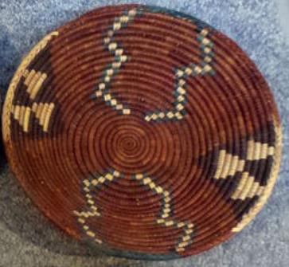
Case No.:
Accession Number:
Formal Label:
Display Description:
Navajo of northern Arizona.
LC Classification:
Date or Time Horizon:
Geographical Area:
Map:
GPS Coordinates:
Cultural Affiliation:
Medium:
Dimensions:
Weight:
Provenance:
Condition:
Discussion:
References:

